Cartridge Material System Operation and Maintenance Manual

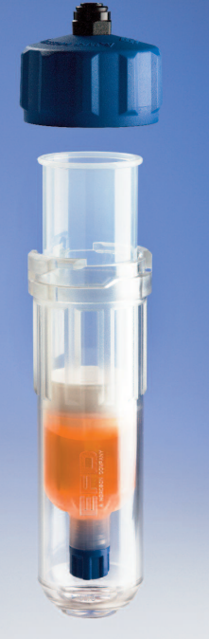Massivit 1800

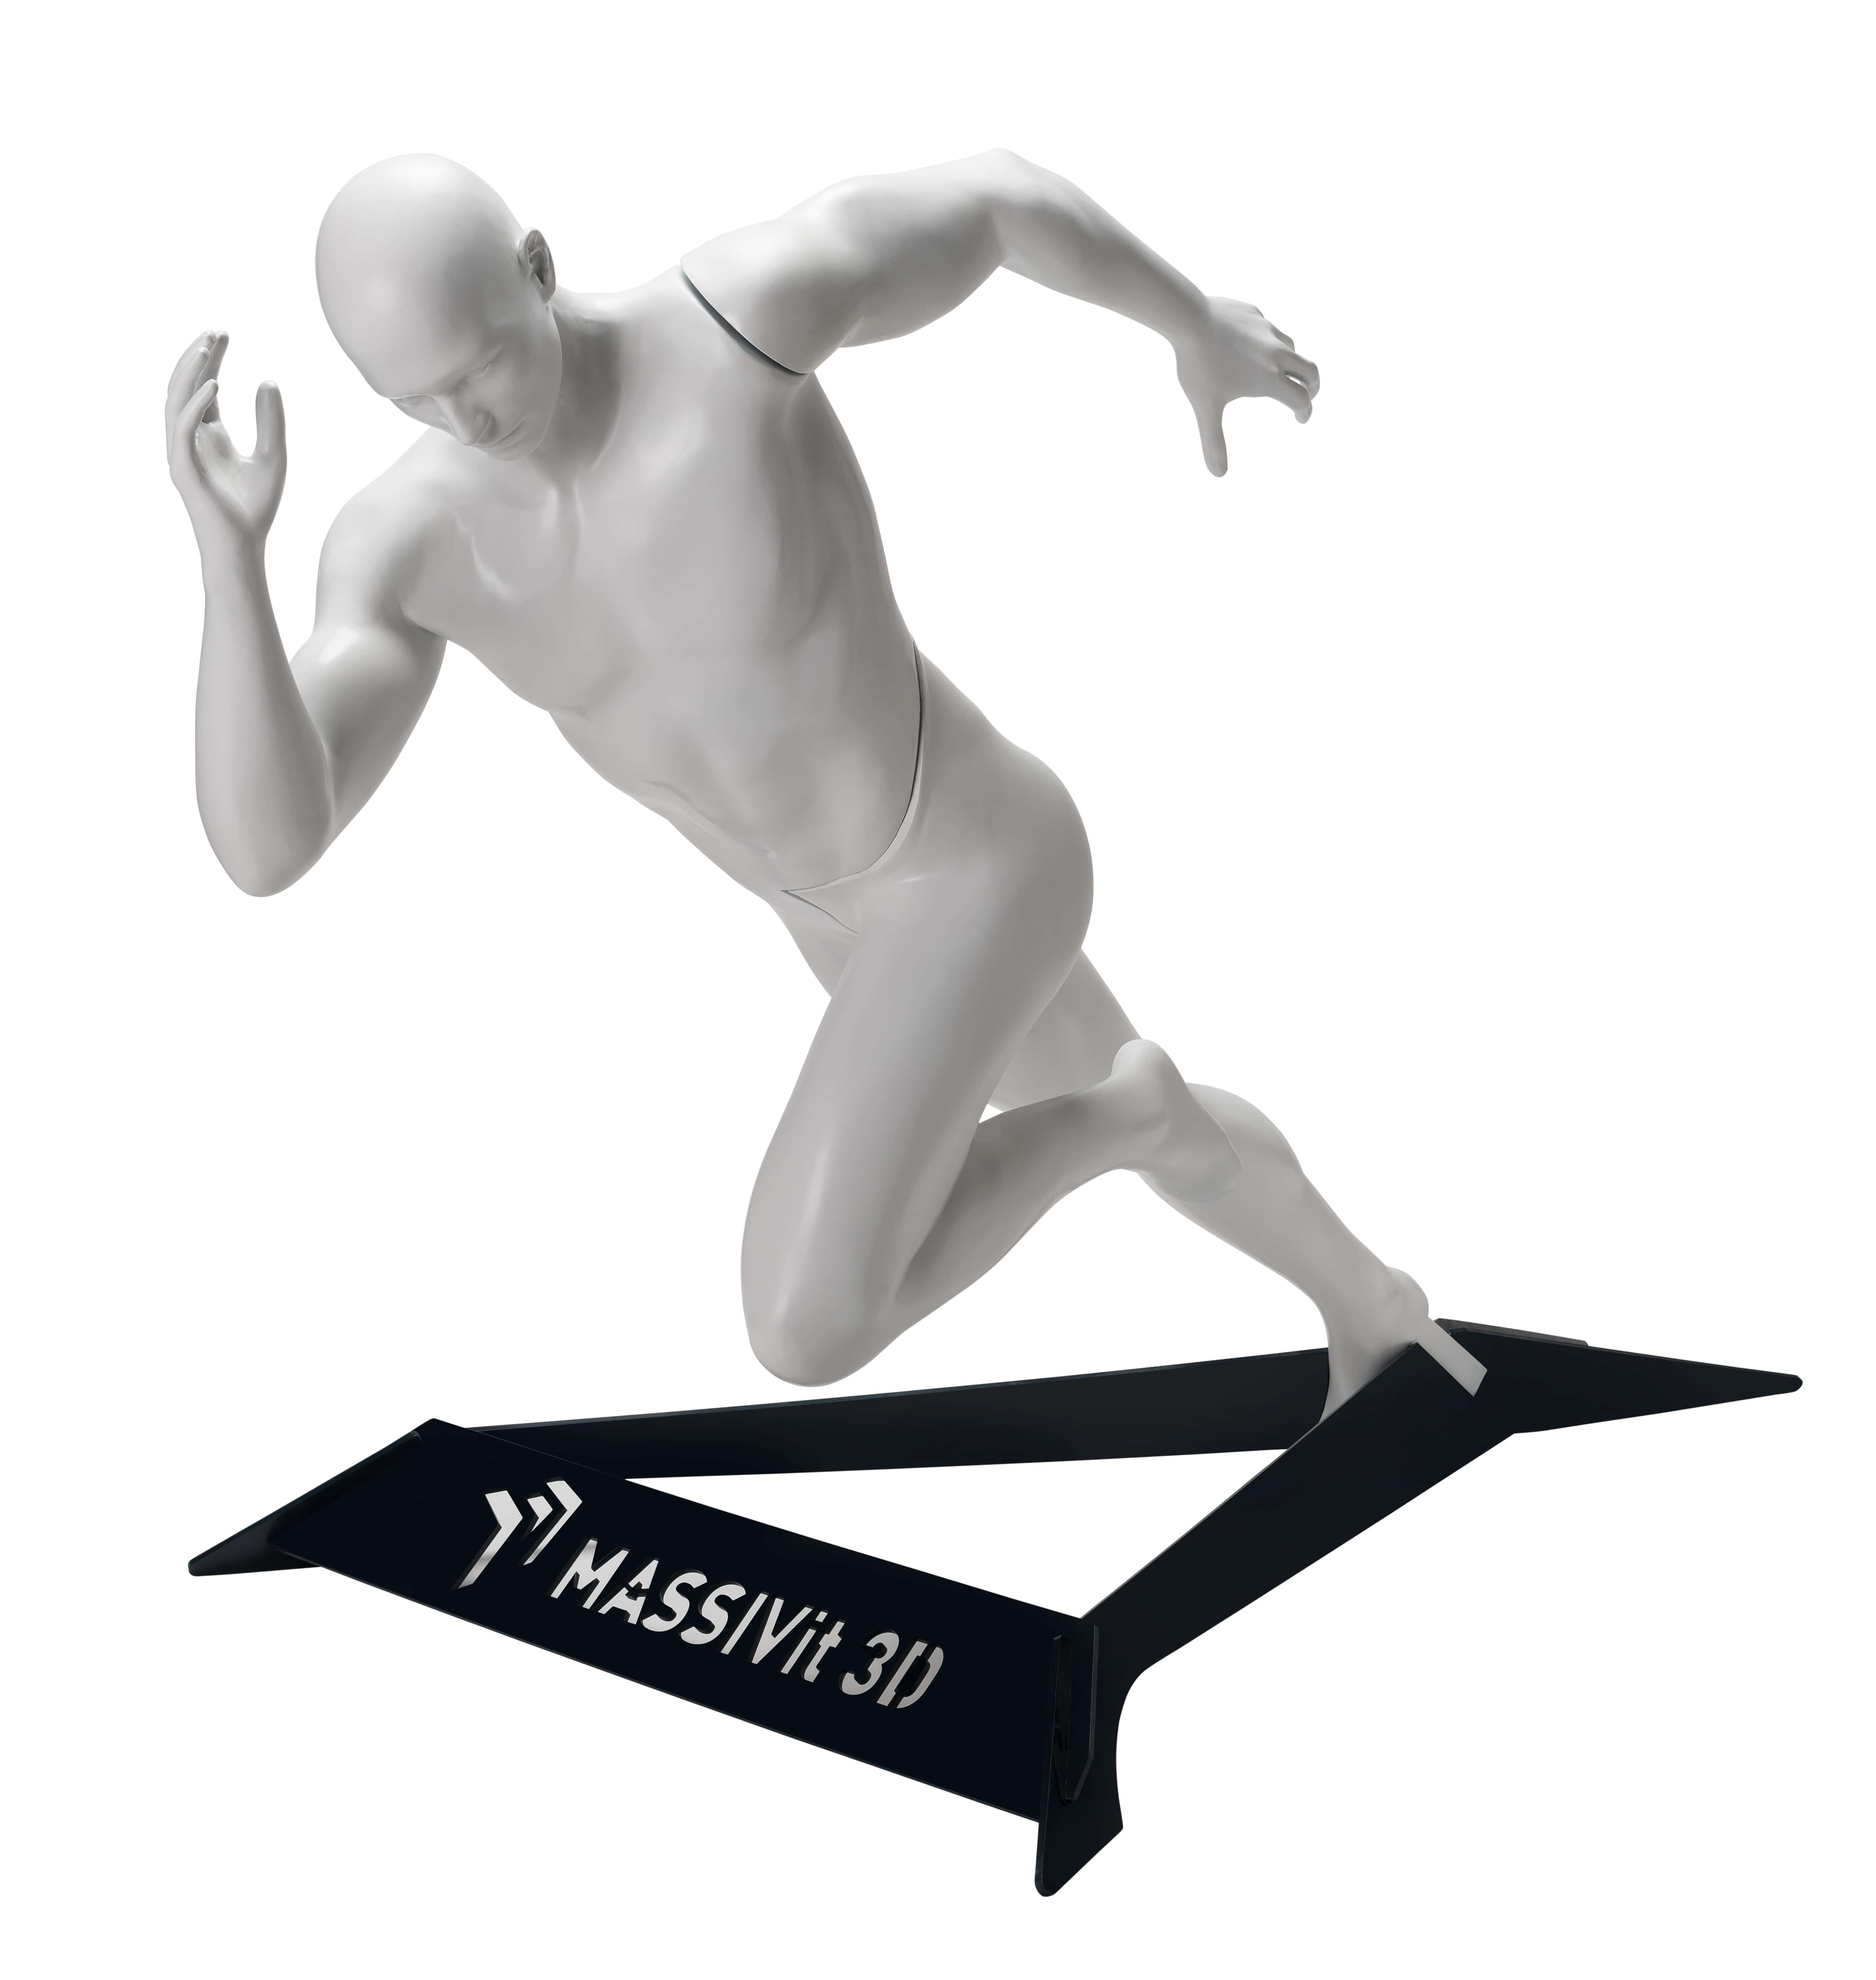

MASSIVit Website: http://massivit3d.com

Customer support: [support@massivit.com](mailto:support@massivit.com)

Rev: A Nov 2018

Edit by: Daniel Shizaf

Contents

1. Safety Instructions 3

2. Introduction 4

3. Machine Setup 5

4. Material Loading 7

4.1. Printer Preparation 7

4.2. Cartridge installation inside the Retainer 9

4.3. Install the retainer on the machine 10

4.4. Air Bleeding 12

5. Replace Cartridge 14

5.1. Printer Preparation 14

5.2. Cartridge Removal 14

6. Maintenance 15

7. P/N LIST- 16

1. Safety Instructions

Pressurized tubing can be very dangerous. Tubing whose integrity is compromised due to wear, damage or misuse can develop a leak, spraying materials at high pressure. This spray can enter the eyes or cover the skin or cause other serious bodily injury, fire or property damage. Before pressurizing any system, examine all tubing for cuts, wear, bulges and leaks. If any of these conditions exist, replace the tubing immediately with approved tubing. Do not try to repair a damaged tube.

BE SURE all tubing connections to the system are properly secured.

BE SURE that the material to be dispensed is compatible with the tubing and dispenser system.

Always wear appropriate protective equipment as glasses, gloves and clothing suitable for your dispensing application.

• Do not exceed maximum operating pressure of 6 bar (87psi).

• Do not heat syringe barrels or cartridges to a temperature greater than 100°F (38°C).

• Do not clean components with strong solvents (e.g. MEK, Acetone, THF).

• Cartridge retainer systems should be cleaned with mild detergents only.

1. Introduction

The machine is a customized version of the Massivit 1800. The machine has two heads, the left head is connected to the bucket feed pump as described in the user manual. The right head is customized and its dispenser is fed by cartridges, the following guide describes specific replacement, maintenance and safety instructions specific to the cartridge system.

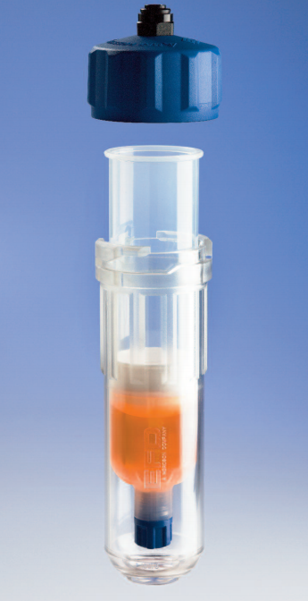

Retainer Cap

Cartridge (consumable)

Retainer

1. Machine Setup

Air pressure setup: Air pressure setup is configured for 3 bar suitable for DM100 viscosity. For higher viscosity consider increasing the retainer pressure slightly in order to achieve a dispenser pressure of ~1bar during printing (do not exceed 6 bar retainer pressure).

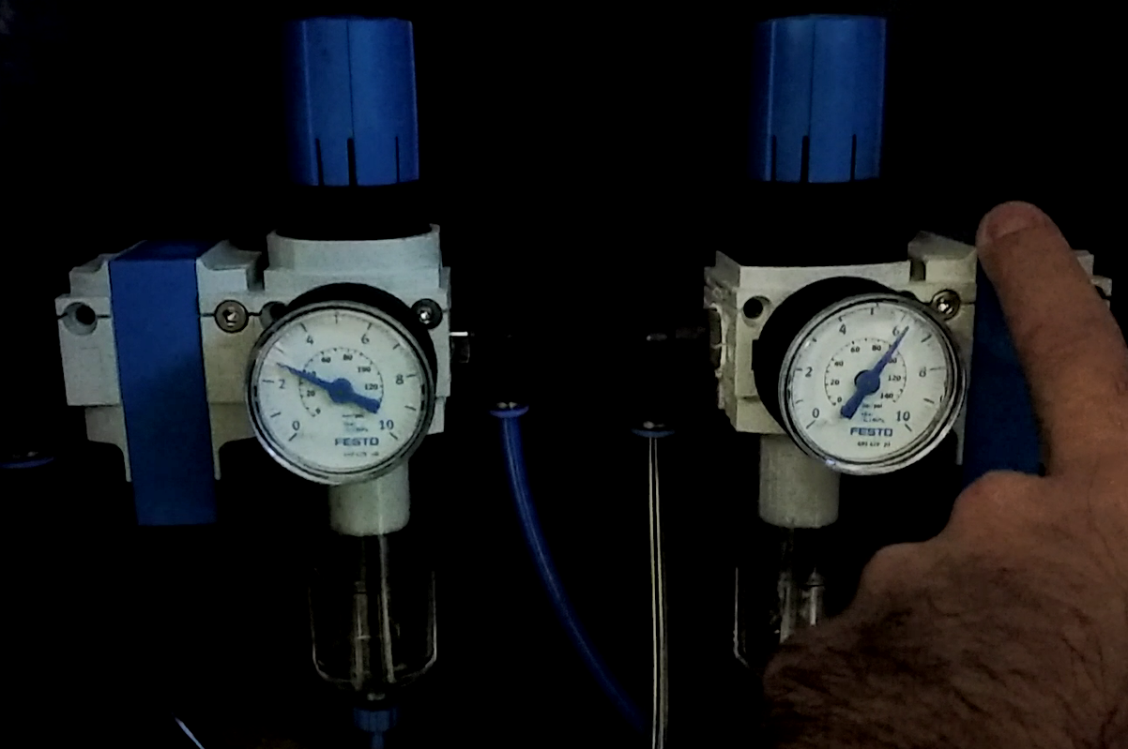

Left pressure regulator (for ratiner) right pressure regulator (main pressure)

Set to 3 bar set to 6 bar

Cartridge quantity indicator

Tap main menu 🡪 material 🡪syringe

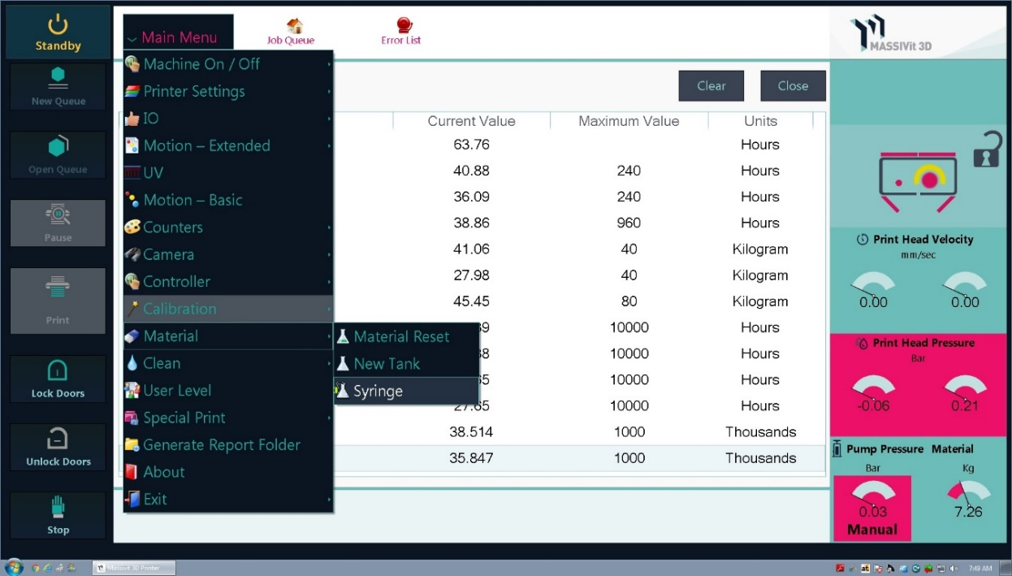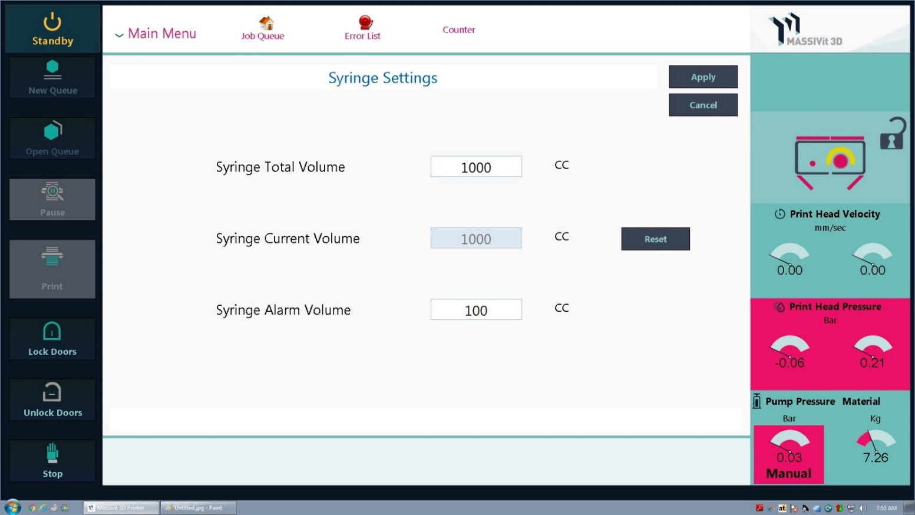

* **Syringe total volume-** please insert the real material quantity in the cartridge.
* **Syringe current volume-** after loading the new cartridge and the retainer in to the machine please tap reset. When you are printing/jogging out material from the dispenser the counter will run, and it will be your indicator for cartridge quantity in real time.
* **Syringe alarm volume-** insert a value that you want the printer will alarm/stop the printing when the counter gets this value.

Note: if material is done in the cartridge the head pressure will drop to zero, this is another indication of material done.

1. Material Loading
   1. Printer Preparation

* Switch to machine on.
* tap machine on and wait to complete

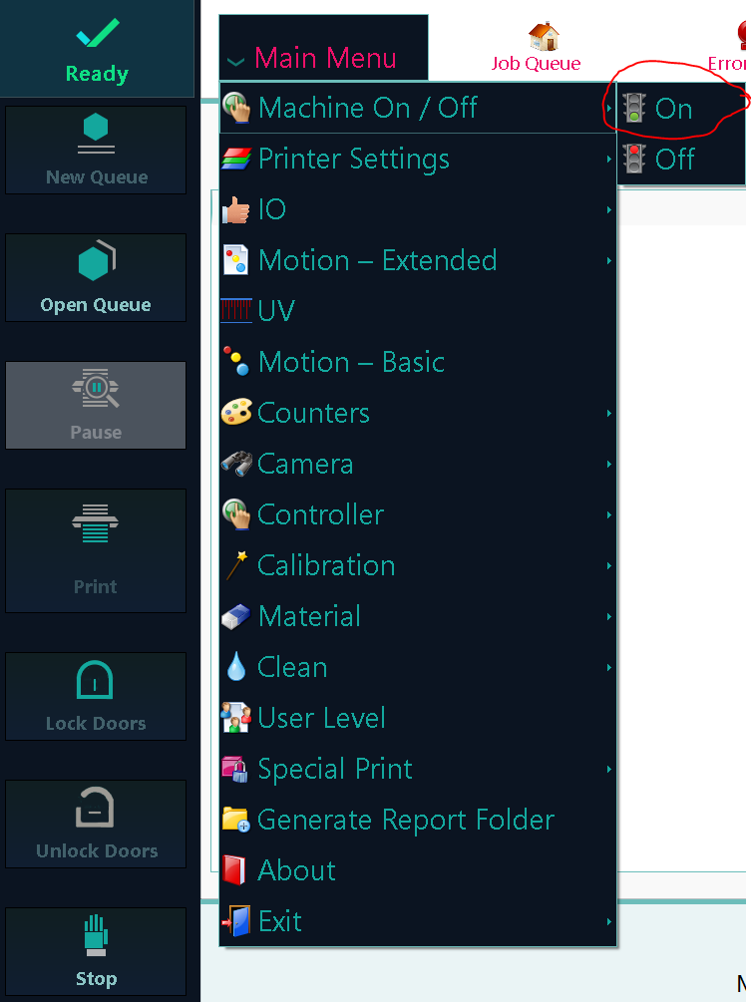

* Tap motion-extended 🡪 virtual global Z 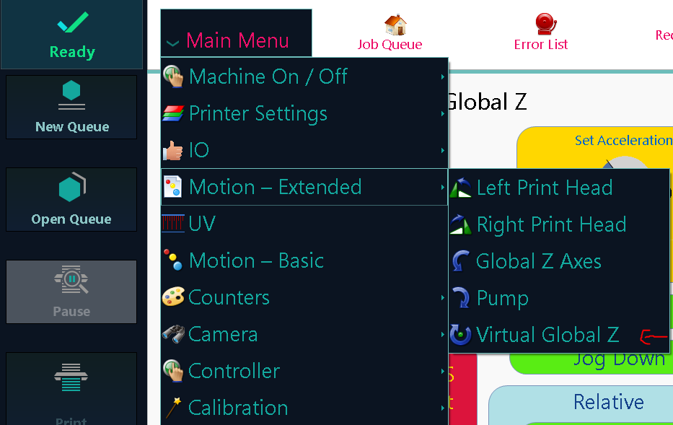
* set 1200 mm in absolute 🡪 tap move and wait to complete

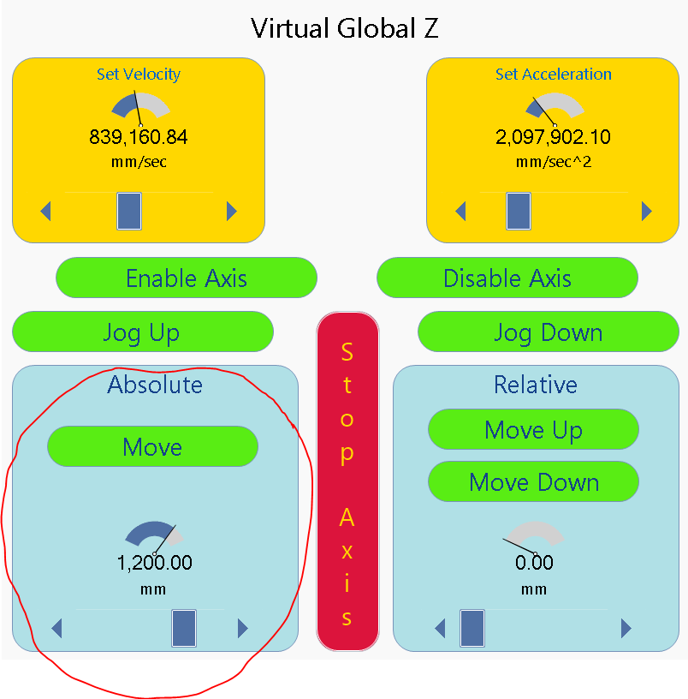

* Press on the emergency red button to ensure no motor movement while inside the machine.

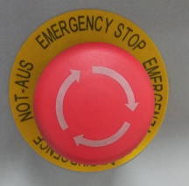

* Place a maintenance mat on the print table to avoid glass damage
  1. Cartridge installation inside the Retainer

Note: This activity is performed on a work bench outside the machine

* Fill up the cartridge with the printing material

Please note:

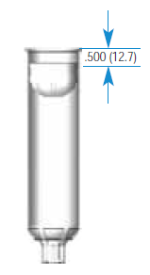When filling a cartridge, leave a gap of at least 0.5 inches (12.7mm) between the top of the piston and the top of the cartridge so that the cartridge back cap can be installed.

* Insert the new cartridge in to the retainer.
* Place the retainer cap on the retainer body.
* Twist the retainer cap clockwise until it locks in place and the arrow below the lock icon on the cap aligns with the arrow on the retainer body.

**Note**: It is very important to ensure proper locking of the retainer cap onto the retainer body as both are later pressurized. Improper closure may result in the retainer cap disengaging from the body upon application of air pressure.

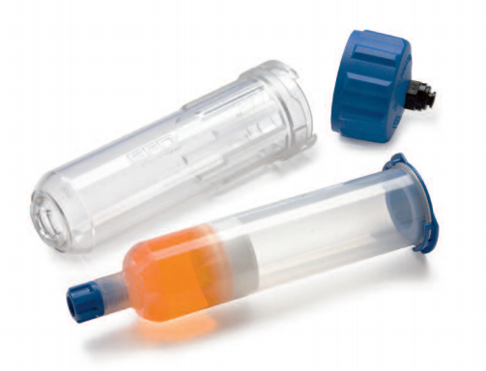 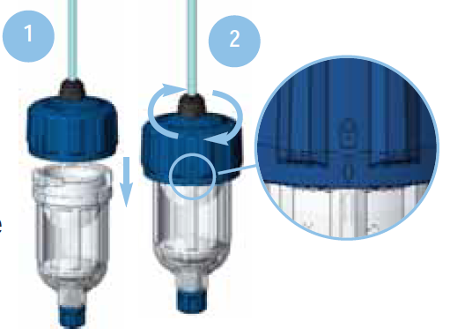

* 1. Install the retainer on the machine
* 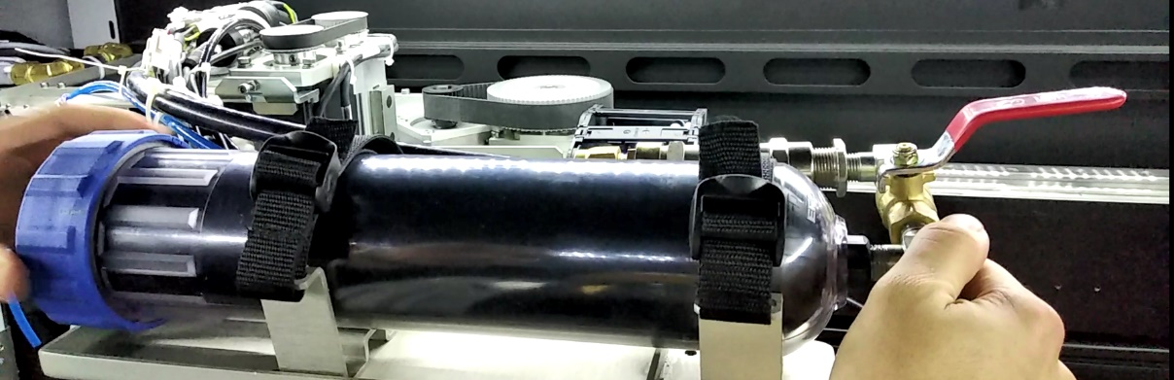After making sure the cap is closed, take the retainer and place it on the two holders on the right bridge.
* Remove the small blue cap from the cartridge Barrel.

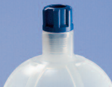

* 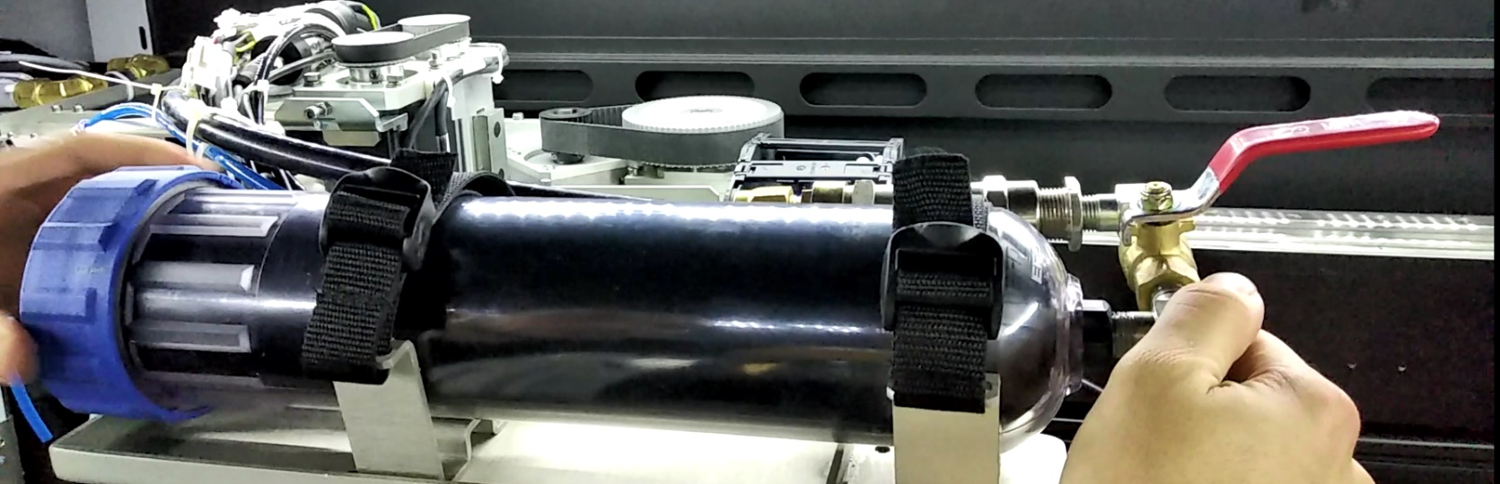Connect the cartridge thread to the material fitting by twisting the retainer clockwise.
* Insert the air pressure pipe into the air fitting by pushing firmly into the quick fit coupling.

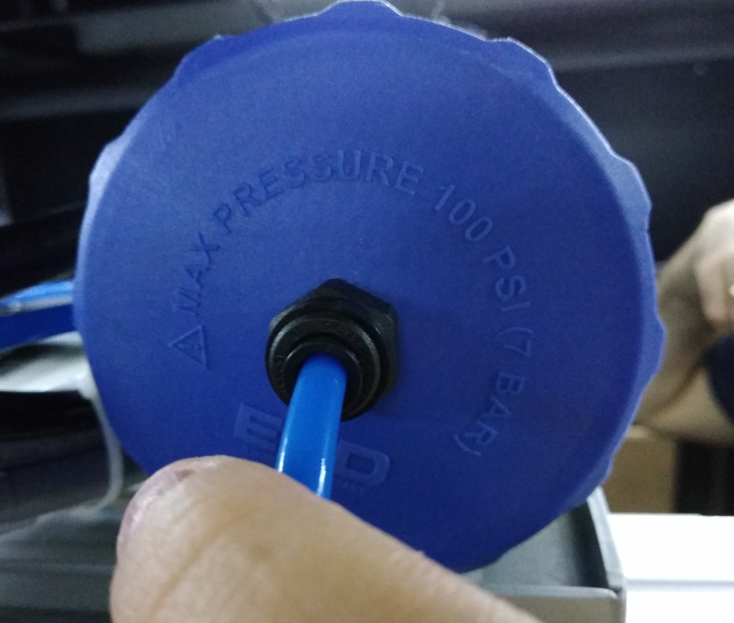

* Secure the retainer in place using the safety straps.

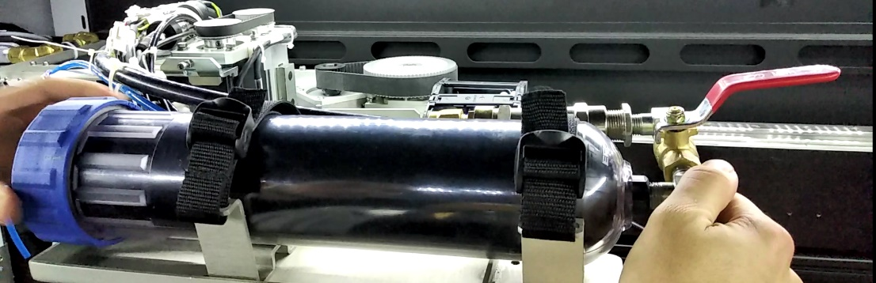

* Open the material valve

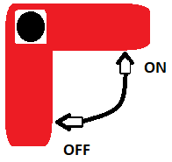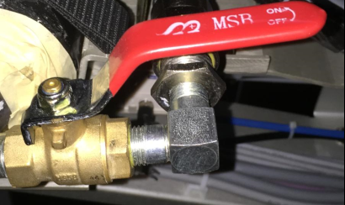

* Open the air valve

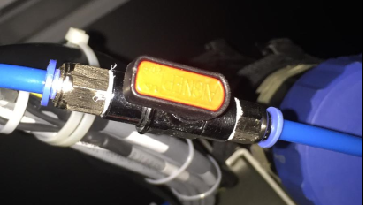

* 1. Air Bleeding

Upon replacing the cartridge some air is trapped in the material pipes. In order to perform quality printing, it is advised to drain the material in the pipes (approximately 150gr) through the dispenser nozzle until material coming out no longer has air bubbles in side:

* Place a suitable container under the dispenser tip
* Tap main menu 🡪motion basic 🡪Printing head 1

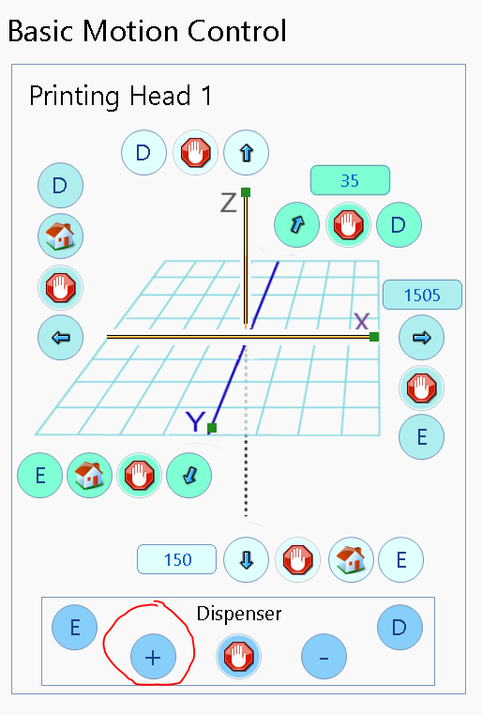

* Observe the material coming out of the dispenser tip and wait until the new material is flowing constantly out of the dispenser and there are no more air bubbles (this should happen after approximately 150 gram)
* Tap stop (main menu 🡪motion basic 🡪Printing head 1🡪 Dispenser STOP)
* If you switched material type, please perform Material Calibration before print start to calibrate the material’s specific gravity: Main menu 🡪calibration 🡪 material adjust
* The machine is now ready to print.

1. Replace Cartridge
   1. Printer Preparation

* Repeat section 4.1
  1. Cartridge Removal

** please follow this instruction closely paying attention to safety aspects listed bellow

* Close the material valve

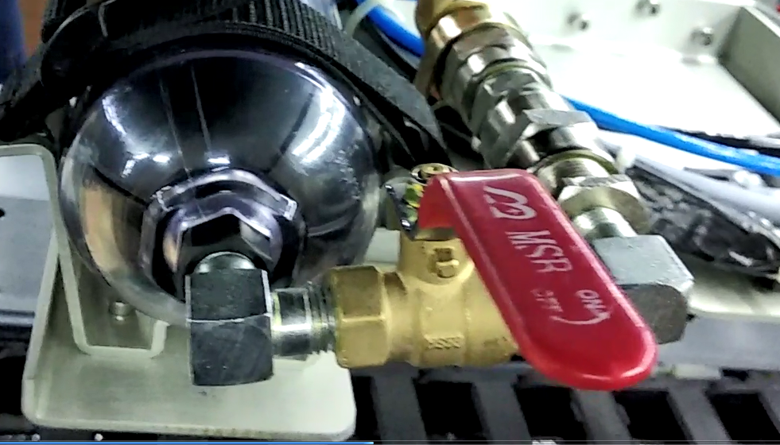

* 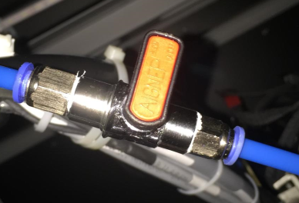Close the air valve and wait until all the air is exhausted from the pipes and retainer.
* Disconnect the air pipe by pressing on the plug and pull the pipe out (don’t pull hard)
* Release the strips that hold the retainer in place.
* Holding the material pipe valve, twist Counterclockwise the retainer to disconnect it from the material fitting.
* Remove the retainer and cartridge from the machine
* For stop material leak from the end of the fitting pipe please connect end cap.

1. Maintenance

* Clean the retainer after every use to avoid material curing and clogging the system.
* Clean system with mild cleaning solution, do not use strong solvent.
* Inspect retainer cap O-ring periodically for wear. If its damaged or missing replace it
* Look for air/material leaks, search for material on the material pipes or ear air leak.

1. P/N LIST-

|  |  |  |  |  |
| --- | --- | --- | --- | --- |
| picture | Catalog number | Discerption | Quality | Size |
|  | P/N 7013899  Nordson | Retainer system  Inc.  Cartridge, Buna outlet cap, end cap | 1 | 32 oz |
|  | P/N 7014091  Nordson | Cartridge | 1 | 32 oz |
|  | P/N 7012421  Nordson | Piston wiper | 1 | 32 oz |
|  | P/N 7026917  Nordson | Retainer cap O-ring | 1 | 32 oz |
|  | P/N 7012428  Nordson | End cap | 1 | - |
|  | PCM-00010 (Massivit PN) | Air pressure regulator | 1 | - |
|  | FTG-00193  (Massivit PN) | ¼-6 mm  ELBOW 1/2" TO 6MM QUICK CON  PL6-04 | 1 | ¼”-6 mm |
|  | FTG-00103  (Massivit PN) | ELBOW 1/2" TO 12MM QUICK CON | 1 | 1/4”-12 mm |
|  | FTG-00043  (Massivit PN) | FITIING, T, UNION, D=12 | 1 | 12 mm |
|  | TUB-00012 Black  (Massivit PN) | TUBE POLYURETHANE 12X8 BLACK | 1 | D=12mm  L= 36 cm |
|  | TUB-00120 Blue  (Massivit PN) | TUBE, NYLON, 6X4, BLUE | 1 | D=6  L=10m |
|  | Screw (Universal) | M4-45 | X2 | - |
|  | I66002 (Yeruham automation) |  | 1 | D=6 |
|  | JPC06-1/8 (Yeruham automation) |  | 2 | 1/8”- 6mm |
|  | 90M-0404-NPT (Lia Hydraulics) | Elbow ¼” M-M | X2 | - |
|  | 7973003025 (Lia Hydraulics) | Valve 2 way  ¼” F-F | 1 | ¼” |
|  | PF-04BSP (Lia Hydraulics) | Cap ¼” F | 1 | - |
|  | B-0804-NPT (Lia Hydraulics) | ¼”-1/2” F-M | 1 | - |
|  | MU-0808-BSP (Lia Hydraulics) | 1/2”-1/2” M-M | 1 |  |
|  | MUFA-08-BSP (Lia Hydraulics) | ½” F-F | 2+ | - |
|  | FTG-00062  )Massivit PN) | Stiffener sleeve,14,12,brass | 1 | 12-14 MM |
|  | FTG-00023  (Massivit PN) | MALE ADAPTOR UNION, STRAIGHT, 14MM TO 1/2 NPT | 1 | ½”-14 MM |
|  | Universal | 16mm pipe standoff clamp | 1 | - |
|  | TUB-00114  (Massivit PN) | 14mm Pipe | 1 | 0.5 m |
|  | Universal | Tie Straps | 2 |  |